**Lesson 15 Cíntia Domingos**

**Beet Seed**

**1.**

Bug 1

<https://beetroot2024.atlassian.net/browse/SCRUM-84>

Bug 2

<https://beetroot2024.atlassian.net/browse/SCRUM-85>

**Mighty Beet**

**2.**

* **‘Log in to Patient Account’ in the header**

Font: mayo-sans

Size: 16px

Colour: 8, 8, 8

Background colour: #ffffff

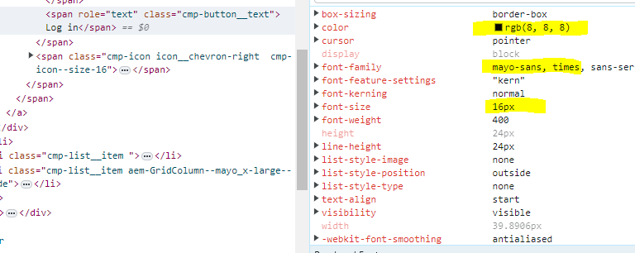 

* **‘Learn more about Mayo Clinic’ button**

I didn’t find a button with this exact text, but there is a “Learn more about our top-ranked specialties.” button on the main page, which is what I used

Font: mayo-sans

Size: 20px

Colour: 0, 87, 182

Background colour: #ffffff

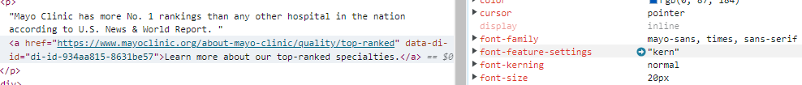



* **feedback rate buttons (numbers from 1 to 5, presented within feedback form which can be called by click on Feedback button (bottom-right corner))**

Font: open sans

Size: 12px

Colour: 0, 0, 0

Background colour: 255, 255, 255

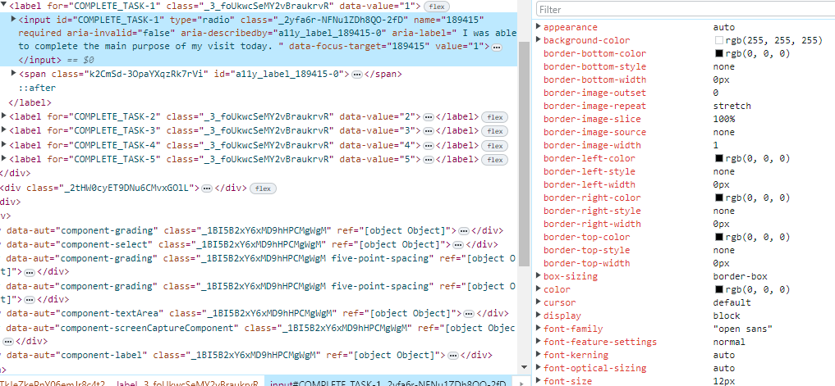

* **Language labels for language change**

Font: mayo-sans

Size: 16px

Colour: 8, 8, 8

Background colour: #ffffff

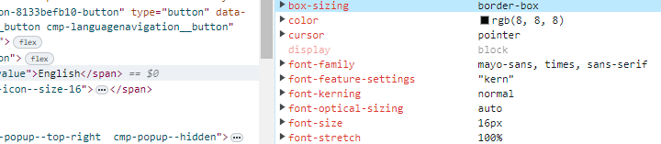



**Additional Task**

**1.**

xpath=//a[contains(@href, '://ce.mayo.edu/otorhinolaryngology')]

xpath=//a[@class='flexitem' and @href='https://ce.mayo.edu/otorhinolaryngology']

css=a[href='https://ce.mayo.edu/otorhinolaryngology']

css=a[href$='otorhinolaryngology']

**2.**

xpath=//*[@title='Events']

xpath=//a[@href='https://alumniassociation.mayo.edu/events/']

css=a[title='Events']

css=a[href='https://alumniassociation.mayo.edu/events/']

**3.**

xpath=//button[@class='btn-prev']

xpath=//button[@type='button' and @class='btn-prev']

css=button[class='btn-prev']

css=button[type='button'][class='btn-prev']